**3 Airflow DAG Examples with Dask**

**Richard Pelgrim • January 7, 2022**

<https://coiled.io/blog/3-airflow-dag-examples-with-dask/>

Objective : POC of Dask implementation on Airflow

Airflow executor: Celery

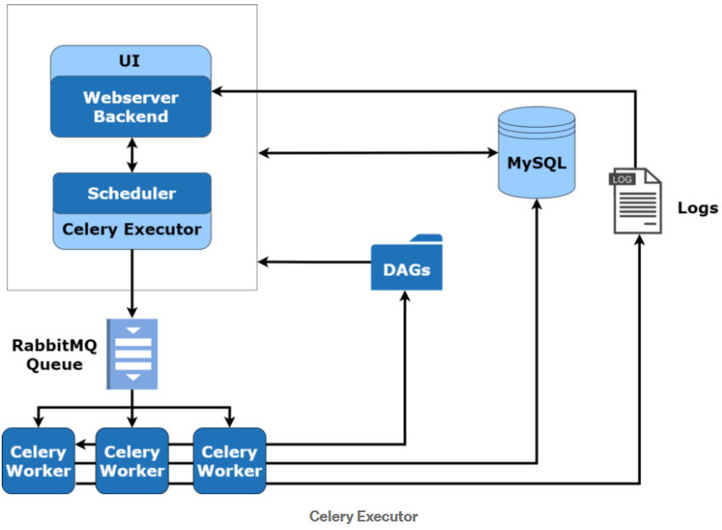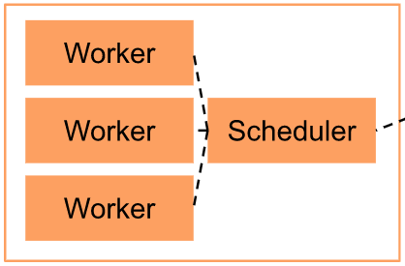

An important tip from Richard Pelgrim

AIRFLOW__CORE__ENABLE_XCOM_PICKLING: 'true'

Github repo:

<https://github.com/oyun2/Dask-Airflow-Experiment.git>

|  |  |
| --- | --- |
|  | |
| **Expected result (distributed cluster on Jupyter lab)** | **Airflow result** |
|  |  |
| Why does the Dask cluster not persist the final result on one of the workers as it does with Jupyter lab experiment?  Is it because Airflow pushes the result to Xcom followed by purging the workers? | |
|  | |
|  | Airflow logs’ error |
| Not working | |
|  | |
|  |  |
| Why does the Dask cluster not persist the 9 futures on the workers as it does with Jupyter lab experiment?  Is it because Airflow pushes all 9 futures to Xcom followed by purging the workers? | |